Session 4 - 1

class Animal{
void walk(){
System.out.println("I am walking");
}
}

class Bird extends Animal {
void fly() {
System.out.println("I am flying");
}
void sing() {
System.out.println("I am singing");
}
}

public class Solution{
public static void main(String[] args){
Bird bird = new Bird();
bird.walk();
bird.fly();
bird.sing();
}
}

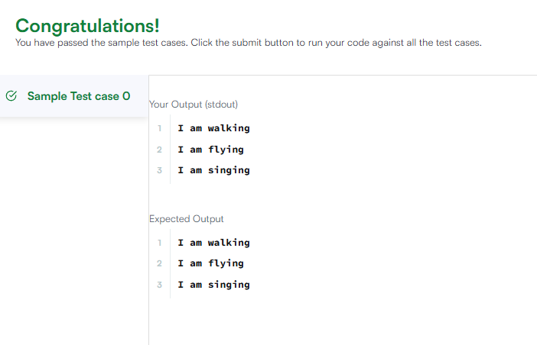

Session 4 -2

import java.io.*;
import java.util.*;

class Arithmetic {
int add(int a, int b) {
return a + b;
}
}

class Adder extends Arithmetic {
}

public class Solution {
public static void main(String []args){
// Create a new Adder object
Adder a = new Adder();

// Print the name of the superclass on a new line
System.out.println("My superclass is: " + a.getClass().getSuperclass().getName());

// Print the result of the subcompilations
System.out.print(a.add(10,32) + " " + a.add(10,3) + " " + a.add(10,10) + "\n");
}
}

